We welcome you this morning as we gather to worship the King and offer a sweet aroma of adoration to our Savior and Lord.
If you are visiting, we extend our warmest greetings and are delighted you have chosen to worship with us. Please complete the Visitor Card placed in this bulletin and drop it in the offering plate.
Prelude
Congregational Singing * Praise Team
Come, Christians, Join to Sing
Welcome & Announcements Spencer Felder
Pastoral Prayer Spencer Felder
Offertory
Call to Worship * Cary Miller
John 14:23-27
Congregational Singing * Praise Team
I Will Glory In My Redeemer
When I Survey the Wondrous Cross
Forgiven Forever **
Sermon Pastor Paul
Benefits of Justification
Romans 5:1-5
Congregational Singing * Praise Team
Lead Me, O Lord
* Please stand.
** Children’s Church dismissal.

Announcements
: 13

New Stage Construction
You will notice that construction on our new stage has begun. Many thanks to Roy Burnett and Joe Minukas for all the work they have done this week. Please be careful in and around the construction and please try to keep your children from playing on or around it. We thank the Lord for providing the means and ability to do this. Please continue to hold this work up in prayer.
New Directory
The new TBC Photo Directory is available at the back table.
TBC Family Hour
Each Sunday, TBC Family Hour will feature something different, such as music/singing, prayer, game or movie night, or a devotional. Join us at 6 - 8 pm this evening for Game Night. Feel free to bring a favorite game and snack to share.
Baptism
Have you been saved by the Lord Jesus Christ but have not followed Him in obedience in baptism? Now is the time. Please see Pastor Paul for more information.
Missionary Search
The TBC Missions Committee is presently in the process of identifying a new missionary to support. If you know of one that is “gospel centered” and located overseas, please contact Spencer Felder.
Partners In Prayer:
During the month of February, we ask that you join us in praying each day for Child Evangelism Fellowship and Teen Missions International. Brochures are available at the back table.
Nursery and Children’s Church

For those who desire –
- Nursery is provided for little ones through age 4.
- Children’s Church is available for grades K – 4. This year the children will be going through the New Generations of Grace Life of Christ, Acts and Revelation curricula. Children may be dismissed by you as indicated with asterisks (**) in the order of service.

Praise & Prayer
: 13

Praise
- God’s Faithfulness!
Prayer
- James Brown: Surgery was canceled because the pre-op biopsy showed that the cancer has spread. He is understandably discouraged. Pray for him and his wife, Jeanette, and the doctors as he awaits test results and seeks more chemo options.
- Yvette Ramkissoon (Spencer’s cousin): The doctor was able to successfully remove the cancer that was, thankfully, on the exterior or her brain. She will now undergo radiation and other treatments. Pray that the treatments will eradicate any remaining cancer, for healing and for her family.
- Lynn Hooper: Her foot is not healing and the doctor says she is not a good candidate for surgery because she may not heal from it. Furthermore, cancer cells have been found in her urine, her abdominal pain is severe and she continues to struggle with her bipolar disorder. Pray for guidance, healing, comfort and peace.
- Kevin Hollowell (Dempseys’ son-in-law): He lost his job at the end of December. Pray for guidance and provision as he seeks a new job.
- Roseanne Hill (visitor to TBC & Ladies Bible Study from TN): She had major surgery for broken bones in her ankle and foot and she is in a lot of pain. Pray for a quick recovery.
- Wayne Rautio (CEF): Continue to pray for the teams who share the Gospel and Bible lessons with the boys and girls. We have no idea how long we will be able to do this, so we are thankful for the teams that are still functioning and for the new teams that are working to get started.

To submit prayer requests, you may use the enclosed card, email to admin@tbc.me or complete the online form by clicking on Prayer Request at www.tbc.me.
Due to space limitations, requests may be edited.

Book of the Month
Putting Jesus in His Place
By Robert M. Bowman Jr. & J. Ed Komoszewski
The central theological distinctive of Christianity---that Jesus is God incarnate---has repeatedly come under fire from adherents to other religions and scholars who interpret Jesus as a prophet, angel, or guru. Putting Jesus in His Place is designed to introduce Christians to the wealth of biblical teaching on the deity of Christ. Using evidence from the New Testament, this book helps readers appreciate the significance of Christ's deity in a personal relationship with Him, and gives them the confidence to share the truth about Jesus with others.

Missions Memo

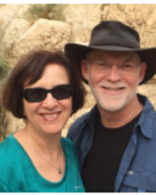
Spotlight on ~
Ken & Joan Hendren
Horn of Salvation
Shalom from Israel! Looking back on 2020, we are thankful for the Lord’s help and strength to continue in fruitful ministry here in the Land, despite adverse conditions amidst the Covid pandemic. We are thankful for opportunities to serve in pastoral ministry at Congregation Or HaSharon, teaching at both Israel College of the Bible and in the Lech Lecha post-army discipleship program, in personal evangelism and other ministry opportunities throughout the past year. We have had to adjust to ministry with masks, social distancing, and Zoom. Though all this has certainly been difficult, we are thankful for the Lord’s guidance, protection and enablement. Your prayers for wisdom and grace to know how to challenge, encourage, and disciple effectively in this situation will certainly be welcome. And of course, I realize that we are not alone in facing such challenges to ministry.
Beside the above, we thank the Lord for our good health and for the provision of vaccines, which we are in the process of receiving. We are also grateful that, to date, our support has not been seriously hurt. In short, we don’t have a strong sense of need except for your prayers for the wisdom and grace to faithfully serve the Lord and his people during this time.
During this month, our congregation received a special monetary gift to help those members who have been adversely affected by the Coronavirus. Some of those who received aid included a single mother who lost her business and needed to move in with her parents, a father with three children who had worked for a hotel (now closed) and is on unpaid leave, and an older woman who cleaned houses and could no longer do so due to recurring, extended shutdowns. Faithful congregational giving will enable us to further help others facing economic hardship as the pandemic continues. We are thankful for the Lord’s provision!
May the Lord bless and keep you, draw you close to Him, use you for His kingdom, sustain you by His grace and love, protect you and encourage you. We thank the Lord for you as our partners in ministry and for your faithful support and prayers.
Yours, “For Zion’s Sake” (Isa. 62:1) Noam (Ken) & Joan Hendren

Our Missionaries:
Child Evangelism Fellowship  Wayne Rautio  Campus Crusade for Christ  Dana Saleeby  Commission to Every Nation  Chad & Kara Mia Dexter | Fellowship of Christian Athletes  Patricia Hollowell  Teen Missions International  Richard & Gina Barber  Horn of Salvation  Ken & Joan Hendren  Missions Memo  : 13

To Memorize This Month
Romans 4:5 – But to the one who does not work, but believes in Him who justifies the ungodly, his faith is credited as righteousness....
TBC Calendar

Today: (*** please see Announcements for details)
- 9:15 am Sunday School
- 10:30 am Worship Service
- 6:00 pm TBC Family Hour ***
This Week:
- Wednesday Youth Group
7:00 pm at the Hensons’
Looking Ahead:
- February 28 Table Talk
- March 9 Ladies’ Bible Study
1:00 pm at TBC & via Zoom
- Oct 15-17,2021 Contending Earnestly for the Faith Conference
Phil Johnson at TBC

Live streaming of our Worship Service is available at our website, www.TBC.me. If you are feeling unwell, please join us from the comfort of your home.

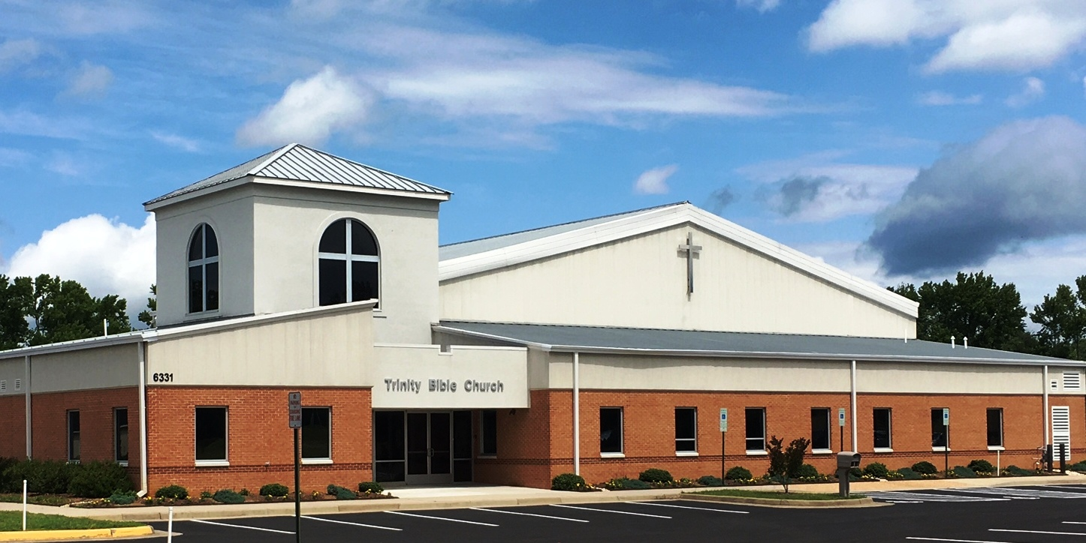
Trinity Bible Church

We gather together this morning
in praise and adoration of
our Lord Jesus Christ,
whose grace is amazing and
whose love is all satisfying.

Come to the
Fall Festival
Tonight!
February 21, 2021
6331 Campus Drive
Fredericksburg, VA 22407
540-548-3444
admin@tbc.me

